New Features

Colored Background or Text
Life is better in color! Now you can add a colored background or colored text for event calendars, events, special days and holidays, and facilities. This way, you can make certain items stand out on your calendars.
Here's an example of how to set up an event with calendar colors:
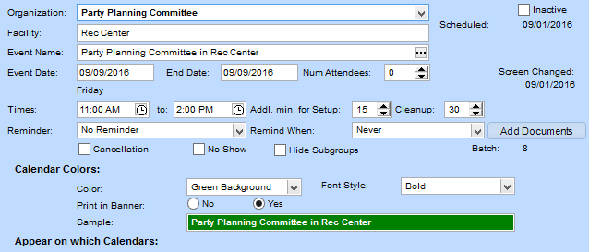
And here's how it shows up on the printed monthly calendar:
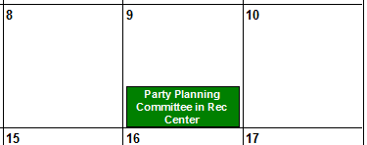

View Addresses on a Map
On all address fields, we added a Map button. Click it to view the address on your favorite mapping service.
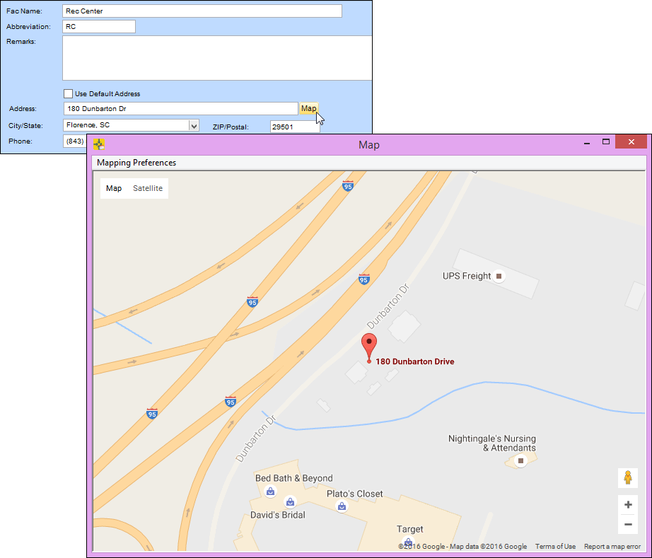

Find Out What's New
Do you read release notes? (Well, you're reading them right now!) We made it easier to get to them from within Facility Scheduler.
When there are new release notes, you'll see the yellow bell icon at the top-right. Once you click the bell and see the release notes, it changes back to white.
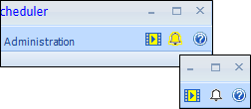

Send Emails to Organization and Facility Contacts
You can now send the results of organization and facility reports to contacts via email. Previously, you could only print letters.
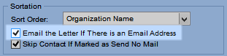

Customize Your Program Name
You can change the name that displays at the top of your program. This is helpful for distinguishing between multiple copies of the program for your parish, school, campus, and so on. For more information, see Customize the Program.

Find All Your Processes in One Place
Have you ever been looking for a process but couldn't remember where it was? Now, you don't have to worry! We moved all your processes under a tab where you can quickly locate them.
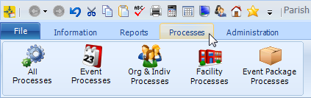
You can still find the related processes under each section, too.

Improved Features

Redesigned Grids and Buttons
We improved the look of grids and grid buttons. Instead of the words Insert or Line Delete, we used the icons you're familiar with for adding and deleting , and a new icon to represent reordering .
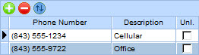

Collapsible Access and Privileges
If you've set up access and privileges, you know how hard it can be to scroll through all the program areas. We redesigned the grid so you can easily see the windows in the program level you want. You can expand and collapse the rows for better viewing.
We also added a handy Find button, so you can search for a specific window or process.
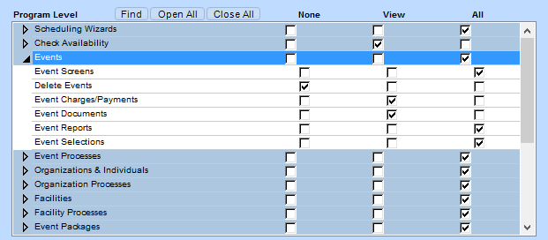

New and Improved Reports

Search for a Particular Report
In the report list, you can now find a report you're looking for without expanding all the groups.

