New Features

Scan and Deposit Checks in PDS
With the new SpeedCheck feature, you can scan a batch of your contributors' checks, deposit them into your church's bank account, and post them in PDS.
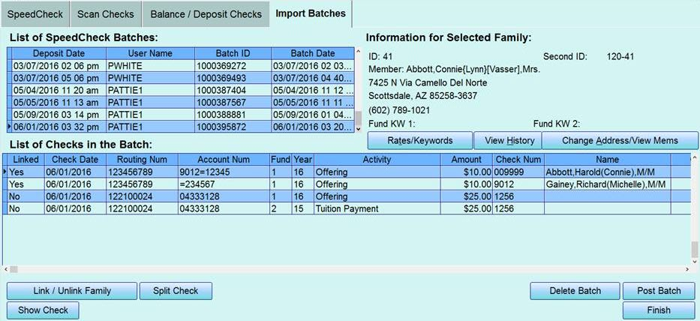
You can even set up Bill Pay accounts to easily connect families you've previously processed.
For more information, visit our website or contact our Sales team at 1-800-892-5202.

Link Members and Personnel
If you have a member in your database, you can quickly add a personnel record with all of their information at the click of a check box.
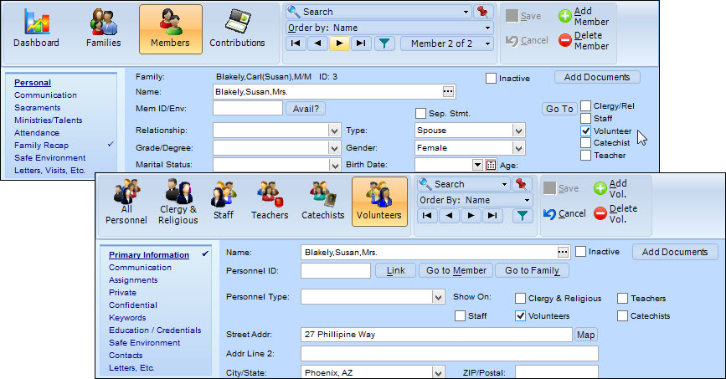
If you have a member record and a personnel record for the same person, you can "link" those. That way, the person's information is always consistent between the records.
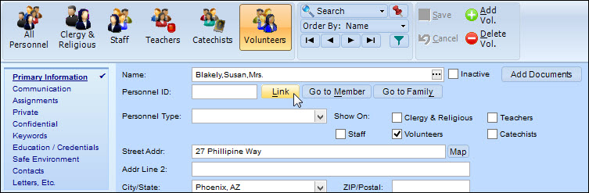
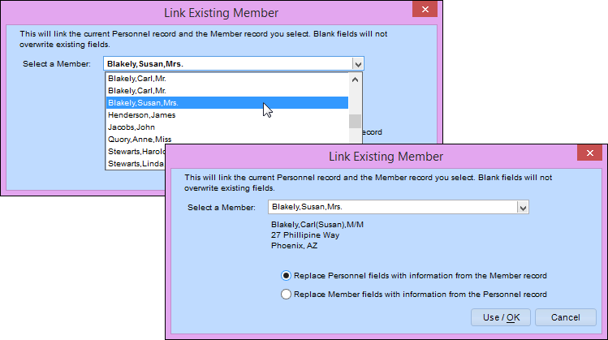
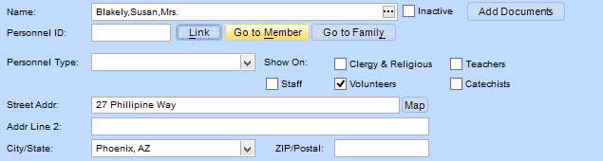

Automatically Check for Duplicates
When you add a new family, the program now checks for duplicate records. This checks existing records that are visible in your program, as well as those in your shared data file.
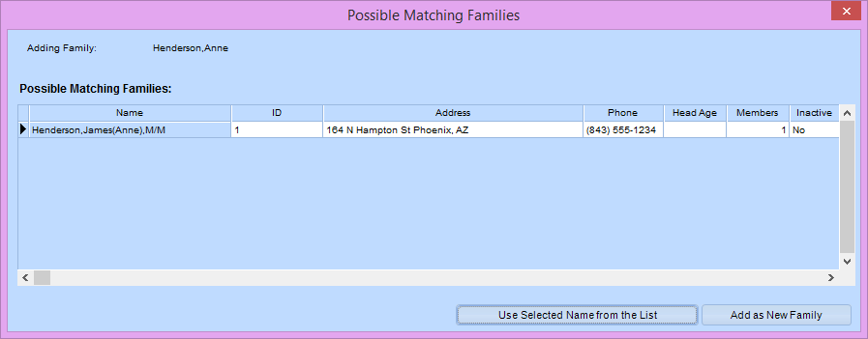
If a match is found in another PDS program, you're prompted with a list of members you can add.

Better Searching
We changed the Search By drop-down list to a new Search dialog box. You have all the options from Version 7, plus some!
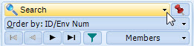
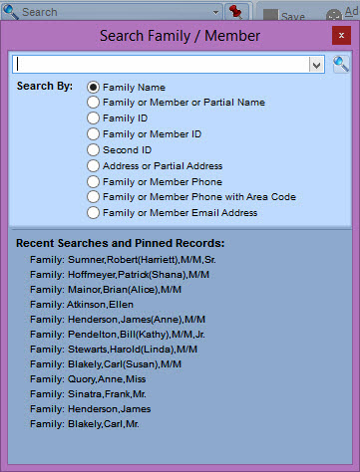
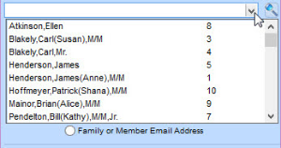
You can also add important records to a "pinned" list, along with your recent searches.
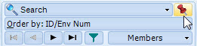
After you add a record, it displays in the search drop-down list.
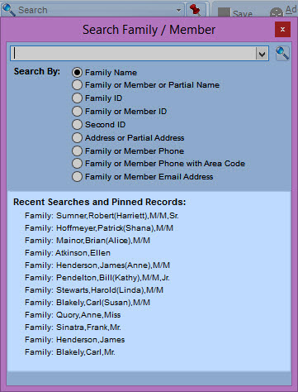

Filter Your List of Records
We added filters to the Families window so you can control which records show up.
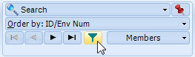
If you select a family record that's not visible in your filter (from search results), the filter is turned off.

Sign Up for Vanco eGiving
We added a link on the Online Resources menu to sign up for eGiving through Vanco.
We now use the term "eGiving" to represent electronic fund transfers (EFT).

Find Out What's New
Do you read release notes? (Well, you're reading them right now!) We made it easier to get to them.
When there are new release notes, you'll see the yellow bell icon at the top-right. Once you click the bell and see the release notes, it changes to white.
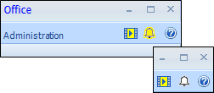

Military Option
We added Military Services as an option in the Diocese/Archdiocese lists on the License window and under sacrament place names and addresses.

Add Families to Other Office Programs
If you share data, you know how tedious it can be to add a family to another Office program.
Now you can add a family to Church or Formation without leaving School Office! On the family's record, click the blue plus button to add the record in Church or the green plus button to add it in Formation.
Once you add the family, the plus buttons change to the Church and Formation icons. In the other programs, the School icon displays on the family's record.

Personnel Report Fields
We added phone number and email address fields for personnel reports. Now you can create reports using these fields like you can for members.
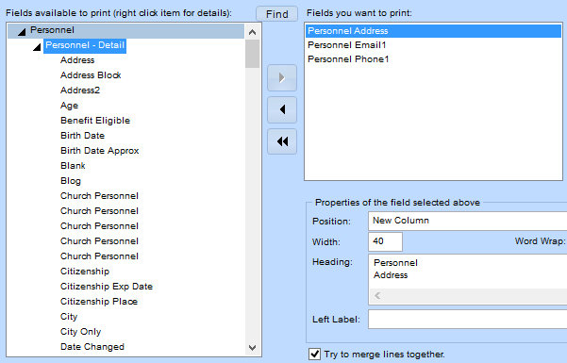

Postal Changes Effective January 22, 2017
The US Postal Service made the following changes:
- Changed Standard Mail wording to Marketing Mail
- Changed the layout on postage statements and forms
- Changed prices for First Class stamps, and First Class and Marketing Mail
- Updated weight limit for piece pricing of Marketing Mail Letters and Flats
- Combined 3-digit and AADC sorting
- Changed FSS Scheme
For more on these changes, see the USPS Overview of Key Changes.
If you're on the latest version, you were prompted to download the latest postal forms on January 22. Otherwise, please update your program to get the changes.

Online Data Security Update
After June 1, 2017, we will disable TLS 1.0 and upgrade to TLS 1.2. This affects all of our public APIs and online payment transactions. If you use those, you must update your operating systems and browsers and inform your congregants to upgrade as well.
For more information on what this means for you, see our official notice for the Security Update for Our API Consumers.

View and Print Changes and Deletions
We added two new options in the User Log. If you selected Ask for Reason on Significant Changes in the Initial Setup window, you can view and print lists of changed items or deleted items.
This selection and any applied filters are reflected when you click Log Report. So you can print a report of only changed items or only deleted items. This is helpful if you have to send these to your diocese regularly.
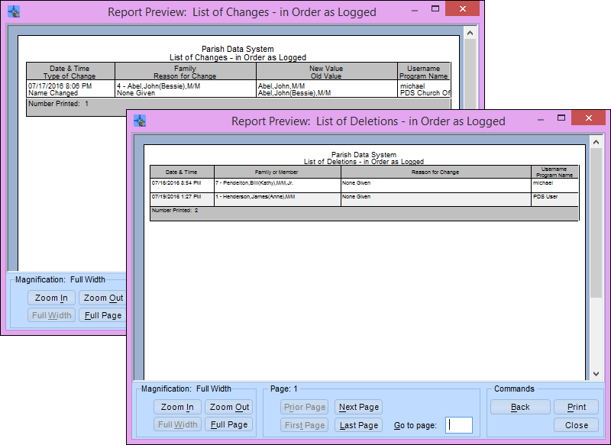

Log Members Marked Deceased
If you log significant changes, now you'll see an entry when a user marks a member as deceased.

Print Possible Duplicates
When adding a family, you can see a list of possible matches to existing families. Now you can print that list.
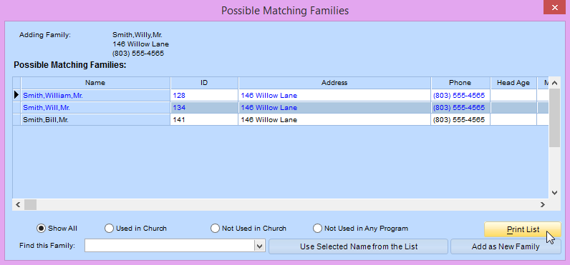
We also added filters for better viewing. You can see all matches, those matching families visible in your program, those not visible in your program, or those in your database who aren't visible in any programs you use.

Warning for Insufficient Funds
If a family has had insufficient funds in the past, you now see a warning when posting payments/donations. This way, you can make sure the family has sufficient funds before posting so you aren't charged bank fees.
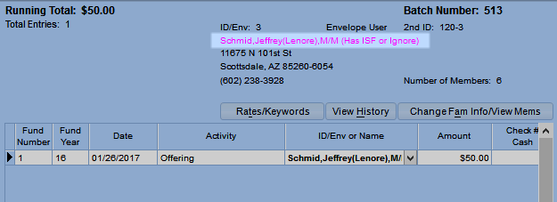
The family's name displays in pink if they have entries posted to Ignore type activities or have "ISF" or "Error" in the check number for the fund period.

Copy Member Communication Info
In the Member Communication window, you can now copy the information from the bottom section to your clipboard. Then you can paste it wherever you need to.
Just click the information you want to copy, and click Yes when you're prompted to copy it.

Add a Record from a Payment Import File
You can now add new students "on the fly" while posting payments using FACTS or Vanco. This is helpful if a student transfers or starts late, and you receive the tuition payment before the student has a record to post to.
If a new student is found in your import file, you're prompted to add a record.
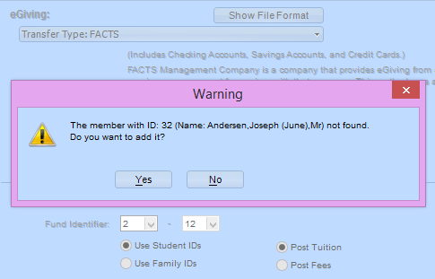

Post Student Type
You can now quickly post student types to multiple records using the Student Type quick posting. This is helpful, for example, if you want to change all 18-year-olds from the type Child to Adult each year before running your annual reports.

Vanco Credits
PDS now handles credited transactions. When you pull online payments from Vanco, any credits back to a family are pulled into PDS as credits, not payments.

Picture Selection
We added the option Has Picture back in report selections. This is useful to see if any family, member, or personnel record is missing a picture.
You can select the option from Fam - Detial, Mem - Detail, or Personnel - Detail.

Improved Features

Revamped Sacramental Registers
The Sacramental Registers have always felt like a separate piece of the program. We revamped it to work more like other records.
Each register now has its own window. You can easily navigate and work with your records.
We also changed the double arrow icon to a Link/Unlink button. This way, you can link a member to their sacrament record.

Redesigned Grids and Buttons
We improved the look of grids and grid buttons. Instead of the words Insert or Line Delete, we used the icons you're familiar with for adding and deleting , and a new icon to represent reordering .
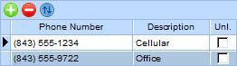

Find All Your Processes in One Place
Have you ever been looking for a quick posting or process but couldn't remember where it was? Now, you don't have to worry! We created shortcuts for all your quick postings and processes under a Processes tab.
You can still find each one under its original section, too.

Collapsible Access and Privileges
If you've set up access and privileges, you know how hard it can be to scroll through all the program areas. We redesigned the grid so you can easily see the windows in the program level you want. You can expand and collapse the rows for better viewing.
We also added a handy Find button so you can search for a specific window or process.
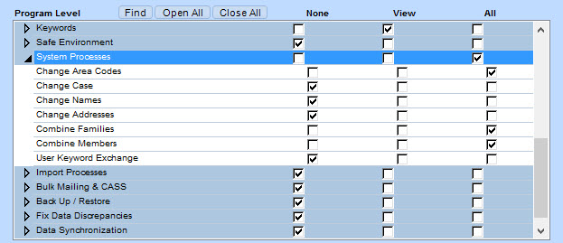

Post Based on Financial Selections
We added the ability to include fund selections during family quick postings.
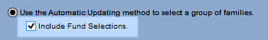
That way, you can post information to families and members based on financial data.
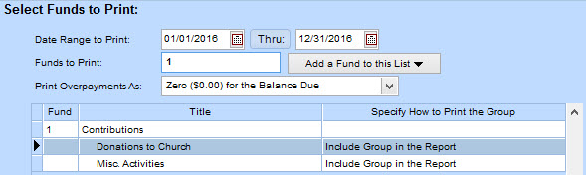

Mark All Addresses as Unlisted
We added a check box that marks all of a family's or personnel's addresses unlisted. That way, if you have people like police, judges, or celebrities, you can be sure their addresses won't be published in reports that may go out, such as a directory.
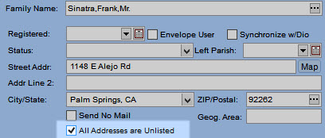
We added an option so you can decide how to print these in reports.
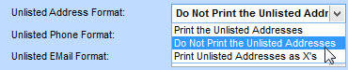

Prevent Duplicate Family Records
We made it easier to find existing families when adding new ones. In the Family Name dialog box, you can enter a couple of characters of the family's last name, then click Apply/OK to see the possible matches.
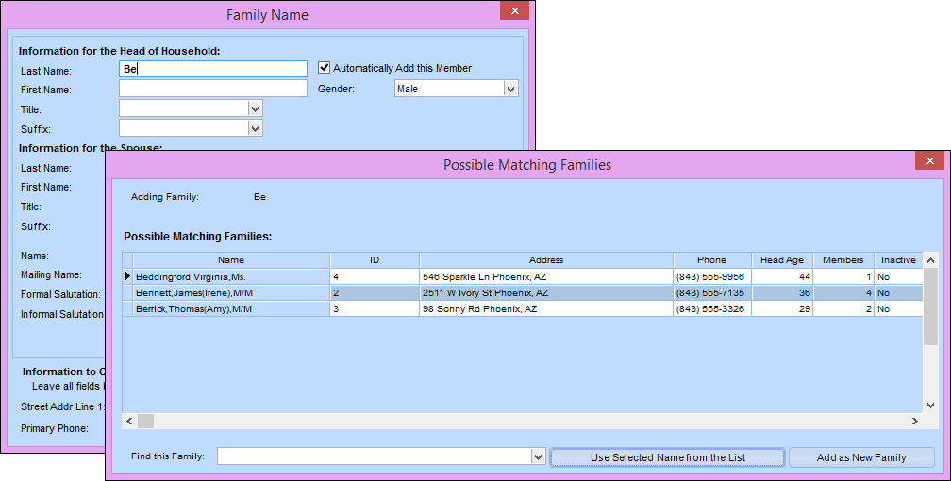
To view a list of all families, leave all the fields blank then click Apply/OK.
For a more refined search, you can always check for duplicates using address and/or phone number.

Quickly Enter Check Numbers
In Payment/Donation Entry quick posting, the check number column is now highlighted when you tab into the field. That way, you can quickly enter what you want without having to remove the default value first.
Now, if you have it set up, the program can speak the value entered in the check number field.

Sacrament Place Phone Number
You can add a phone number for sacrament places you set up.

Special Terms in Pledge Card Entry
In the Pledge Card Entry quick posting, if you set the option to post as Special if the initial offerings match the pledge, the word "Special" now displays in the posting grid and on the report.

Sharing ID Numbers
We made it easier to understand how to share IDs between programs. This way, you can avoid issues where families may end up with the same ID in the same program.

Alternative Way to Add Families
If you don't prefer the new method of adding families, you can use the old process.
Go to the Families window, and press Alt + A, then add the family.

EMM Trays in EZ-Mail
We modified the EZ-Mail process to support EMM letter trays. In Step 1, select the type of trays you need.
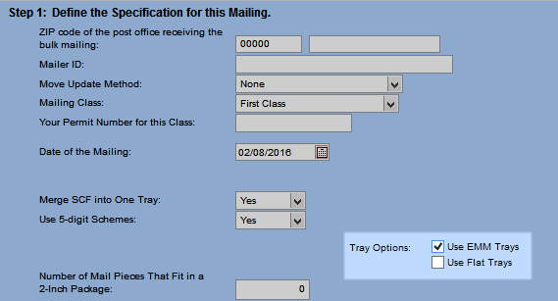
We updated the postage statement so the information prints correctly on the form.

Import Acceptiva Batches
If you use Acceptiva to process transactions, you can now import your batches into PDS. For more information and steps on importing, see Post eGiving.

More Control for Changing Case
We overhauled the Change Case of All Information process to give you more control over what gets changed. Now, you can select which names, addresses, and other fields are changed to uppercase or upper and lowercase.
For more information and steps, see Change the Case of Information.

Pull In Vanco Family Email Addresses
You can now import family email addresses into PDS from Vanco. In the eGiving quick posting, use the transfer type Vanco–Auto Connect and select Import Email from Vanco.

Canadian SIN in Reports
Last month, we changed the format and label of the Social Insurance Number (SIN) for our Canadian clients (based on the Zip Code entered in your license window).
To top this off, we updated all references to the American term in reports with the Canadian SIN.

Match Pledges with Payments
Sometimes people contribute more than they pledged. On reports, you may want to increase the pledge amount to match the total paid so they show the same amount. We added an option in the Print Overpayments As drop-down list to do that.
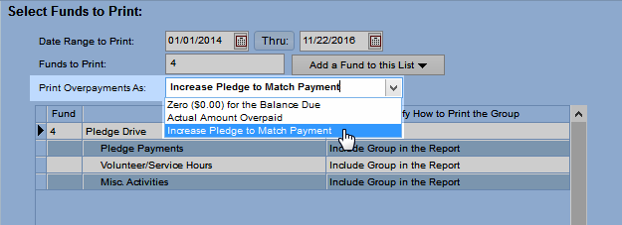

Match EZ-Mail Mailing and Report Dates
Previously when printing mailing labels with an EZ-Mail sort, you received a message if the mailing date was different from the report date. You then had to go back a few steps and manually edit the report date.
Now, the program checks for you and provides an easy way to change the report date to match the mailing date.

Resize Vanco EFT Window
When you view EFT information, the Vanco webpage automatically resizes. Now, you can see all the information within the PDS window.

Import Middle Names
The Family Information import now includes the head and spouse middle names.
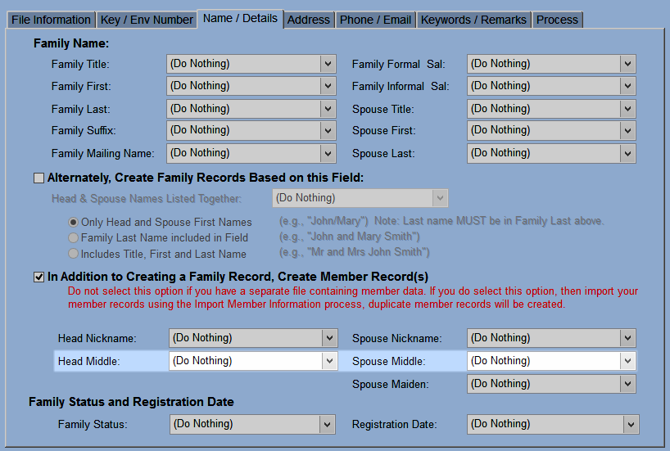

Check for Duplicates During Import
The Family Information import now checks for duplicate families in your current program and any programs you're sharing data with.

Edit Family Information During Posting
Now you can make changes to phone numbers and emails when posting pledge cards or payments/donations. After you select the family, click Change Family Info in Pledge Card Entry or Change Fam Info/View Mems in Payment/Donation Entry.
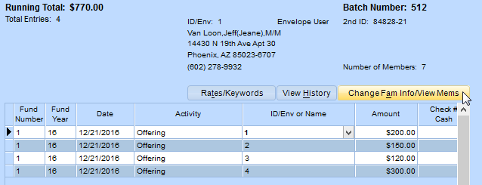
Then click the tabs to view the members in that family and edit phone numbers and email addresses.

Exclude Deleted Family IDs
When checking for available ID numbers, we added an option to exclude IDs of deleted families.
Select this if you don't want to see IDs that have become available again. If you want to reuse IDs, clear the option.
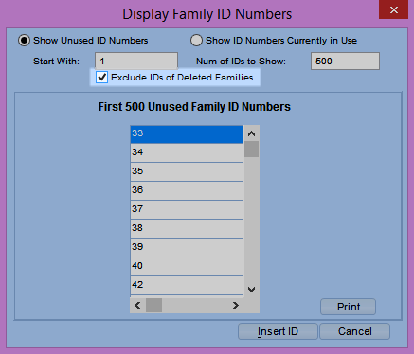

Mark Personnel Inactive
You may have students or parents/guardians who are also personnel. If you mark them inactive, you're now prompted to make the personnel record inactive, too.

Sacramental Register Field View
We changed the field view of Sacramental Registers. Now, the page options are separate from the actual entry. You have all the same options, they're just organized better.
The options refer to the last entry in the register, not the one you're viewing. For example, in the image below, the baptism entry for Jeane Van Loon is in Volume 8, on Page 6, and is entry number 260. The last entry in this register, for your reference, is in Volume 9, on Page 8, and is entry number 360.
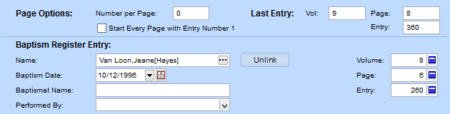

Match Vanco and PDS IDs
When posting Vanco payments, you can match a family using their ID number. Before, you had to go online to update the family's Vanco record. Now, PDS automatically updates that ID number with Vanco.

Unmatched Vanco Families
When posting information from Vanco, some families may not be matched by ID or name/address, or the fund may not be found. If you don't manually match the PDS record or fund, the family is not posted.
Now, the batch report prints entries that were not posted at Vanco or in PDS and entries that weren't selected for posting.
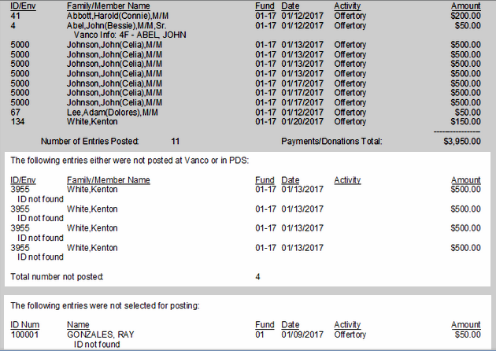

Acceptiva with Family ID
When importing information from Acceptiva, you can now include the family ID number.
If a family is matched using the ID but the name or address doesn't match the record, you'll see a message.

Expanded City/State Field
We increased the character limit for City/State. We're looking at you, Palos Verdes Peninsula, CA!

New and Improved Reports

Sacramental Register Reports
We know you've been wanting to print reports with Sacramental Register information, and now they're here! You can view them on the Reports tab, or on the newly redesigned Sacramental Registers tab.
And like all of our reports, you can copy and customize these, and make selections to get targeted lists of sacrament information.

Updated Canadian Tax Reports
We improved three tax reports: Canadian Tax Receipt, Canadian Tax Receipt - Alternate Format, and Canadian Non Cash Tax Receipt.
You can reprint Canadian tax statements for a family, if needed.
- In the Additional Layout window, there's an option to print a replacement receipt. Make sure to use selections so you only reprint for the family you need.
- Receipt numbers are logged so you can remain compliant with Canadian law regarding charitable contributions.

Custom Emails with Images
You can create and send your own emails using HTML from PDS. Click Add in the Reports window, and click HTML Email.
You can also insert images from your computer or from the web into your email.

Search for a Particular Report
In the report list, you can now find a report you're looking for without expanding all the groups.

